KIỂM TRA ĐỊNH KỲ CUỐI HỌC KỲ I. NĂM HỌC 2025 - 2026 MÔN: TIẾNG ANH LỚP 4
Part II - Reading & Writing (Thời gian làm bài: 15 phút)

Họ và tên: ……………………………………..
Lớp……………… Trường Tiểu học Bạch Thượng

-----------------------------------------------------------------------------------------
Người chấm số 1 (Ký, ghi rõ họ, tên)
Điểm phần Reading & Writing
Bằng số:
Bằng chữ:

Người chấm số 2 (Ký, ghi rõ họ, tên)

Question 1. Choose the odd one out. There is one example. (1 pt)
0 | A. | February | B. January | C. Sunday | D. October
1. | A. | lunch | B. afternoon | C. evening | D. night
2. | A. | teacher | B. singer | C. pen | D. nurse
3. | A. | tiger | B. lion | C. kangaroo | D. fur
4. A. Monday B. April C. Tuesday D. Friday Question 2. Look and read. Put a tick (V) or a cross (X) in the box. There are two examples. (1 pt)
 | 1. These are books. | 
 | 2. Those are motorbikes. | x
 | 3. It’s two forty.
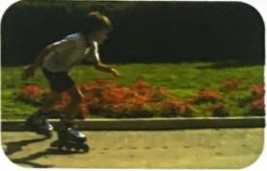 | 4. He likes roller skating in his free time.
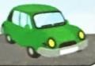 | 5. She goes to work by bus
 | 6. I want to be an astronaut.

Question 3. Look and write. There is one example. (1 pt)
Example:

 | npe | p e n
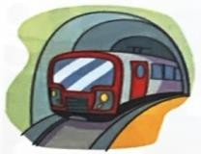 | 1. nuderrgoudn _ _ _ _ _ _ _ _ _ _ _
 | 2. urerl _ _ _ _ _  3. tgier _ _ _ _ _
 | 4. adncre | _ _ _ _ _

Question 4. Re-order the words to make complete sentences. There is one example. (1 pt)
- time/ What / it / is?
=> What time is it?
- love / the / I/ pencils. /colouring / pictures. / drawing /I/ like/
=> …………………………………………………………………………………..
- she /Why /does/ a / teacher? /want /tobe / loves/ she/ Because /teaching. /
=>……………………………………………………………………………………
- would/ like / What/ /eat /to/ you/, /or/ grapes / mangos? /
=>……………………………………………………………………………………?
- does/ My / brother/ karate / and / basketball /time. /plays/ his/ free/in/
=>…………………………………………………………………………………...

