KIỂM TRA ĐỊNH KỲ CUỐI HỌC KỲ I NĂM HỌC 2025-2026 MÔN: TIẾNG ANH LỚP 5
Part I-Listening (Thời gian làm bài: 20 phút) Họ và tên: ………….……………………………..
Lớp……………… Trường Tiểu học Bạch Thượng
---------------------------------------------------------------------------------------------------
Người chấm số 1 (Ký, ghi rõ họ, tên)
Điểm phần listening
Bằng số:
Bằng chữ:

Người chấm số 2 (Ký, ghi rõ họ, tên)

Question 1. Listen and number. (7,5 p)
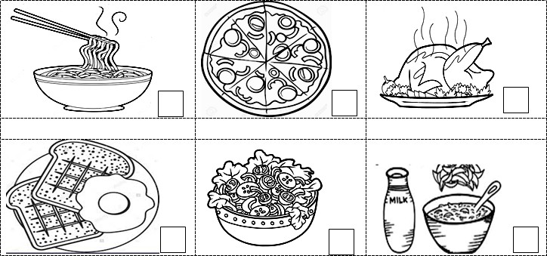
Question 2. Listen and circle the correct sentence. (5,0 p)
- Where is Carol from?
  - She is from the USA
  - She is from the UK.
  - She is from Australia.
- When does she have art lessons?
  - She has it on Tuesdays.
  - She has it on Wednesdays.
  - She has it on Tuesdays and Wednesdays.
- What is Hoa’s favourite thing to do in her free time?
  - She loves sewing.
  - She loves cooking.
  - She loves knitting.
- What food does Jack like for breakfast?
  - He likes cupcakes.
  - He likes sandwiches.
  - He likes noodles.

Question 3. Listen and tick. (6,25 p)
- What subject does Lisa like? - She likes a lot.
A   B.   C.  


- Where’s your new neighbour from? - He’s from

A |  | B. | C.

- What are your hobbies? - I like playing with my friends.

A.   B.   C. 
- How did Sarah go to London?

A.   B.   C.
- Where does Jack want to go during summer? - He wants to go to
A.  B.  C. 
Question 4. Listen and write Yes (Y) or No (N). (6,25p)
 | Y | N
1. The man's name is Mr Gill.
2. He goes shopping in the morning.
3. He likes this supermarket because it is near his house.
4. He always buys milk.
5. He and his daughter go to the supermarket by bus.
The end

