PEOPLE’S COMMITTEE OF DONG VAN WARD
BACH THUONG PRIMARY SCHOOL
School year: 2025-2026

THE FINAL TEST - GRADE 1

TERM 1 (2025 - 2026)
Time: 35 minutes | Part I: Listening: / 2.5 pts
For pupil: | Question 1: / 1.25 pts
Full name: | Question 2: / 1.25 pts
………………………………………………………………………………………… | Part II: Reading & Writing: / 5 pts
School: | Question 3: / 1.25 pts
………………………………………………………………………………………… | Question 4: / 1.25 pts
Class: | Question 5: / 1.25 pts
………………………………………………………………………………………… | Question 6: / 1.25 pts
Date: | Part III: Speaking: /2.5 pts
 | TOTAL: / 10 pts

PART I – LISTENING (2.5 points)
Question 1: Listen and circle. There is one example. (1.25 pts)
Example:

 |  |  | 1. | 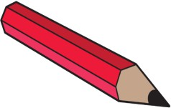 | 
 | A | B |  | A | B
2. | 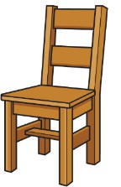 | 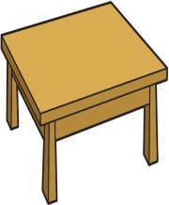 | 3. |  | 
 | A | B |  | A | B
4. |  |  | 5. |  | 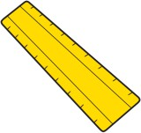
 | A | B |  | A | B
Question 2: Listen and tick (🗸) or cross (x). There is one example. (1.25 pts)
Example:
 | 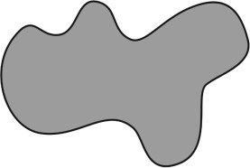 | 1. |  | 2. | 
 | 🗸
3. | 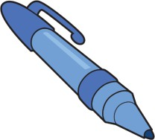 | 4. |  | 5. | 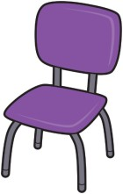

PART II - READING AND WRITING (5 points)
Question 3: Read and circle. There is one example. (1.25 pts)
Example:
 |  | 1. |  | 2. | 
 | pencil / pen |  | eight / seven |  | dad / mum
3. |  | 4. |  | 5. | 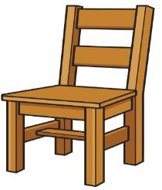
 | pen / rubber |  | brother / sister |  | chair / table

Question 4: Read and put a tick () or a cross (x).
There are two examples. (1.25 pts)
Examples:
 |  | pink | 🗸 |  | four | x
1. | 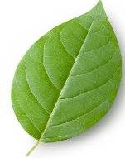 | A leaf. | 2. |  | Five pens.
3. |  | Two rulers. | 4. |  | This is my sister.
5. | 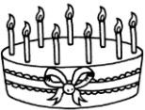 | I’m nine.

Question 5: Fill in the missing letters to complete the words. There is one example. (1.25 pts)
Example:

 | 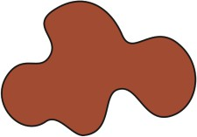 | b r o w n | 1. | 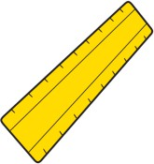 | _ u l e r
2. |  | _ e a d | 3. |  | _ a d
4. |  | _ e b r a | 5. | 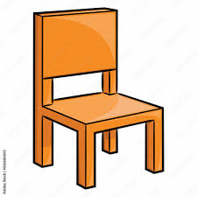 | c h a _ r
Question 6: Look and trace the correct words. There is one example. (1.25 pts)

 |  | six  seven | 1. |  | two  three
2. |  | brown black | 3. |  | ruler rubber
4. | 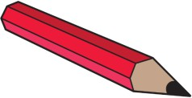 | pen pencil | 5. |  | granny aunt

PART III - SPEAKING (2.5 points)
Question 7:
1. Look, listen and point.
2. Look, listen and answer the questions.

